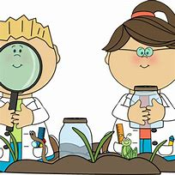



Science

We will be finishing off our learning on living things, exploring habitats and food chains.

We will then begin our plants topic.
we will begin by naming plant
parts and discuss what plants need
to survive.

Term: Spring 2
English

Our main texts this half term will support our To Infinity and Beyond topic: Man on the Moon and Toys in Space.
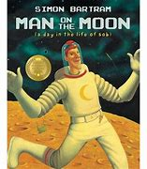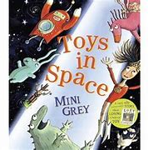

Our writing focus this half term will be writing exclamation sentences, using expanded noun phrases to describe and learn to evaluate our writing.
Year Two - Lons Infant School
Oak Class
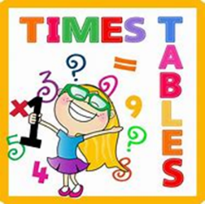
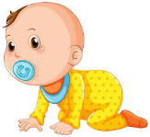
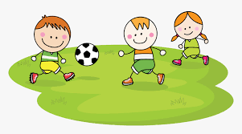
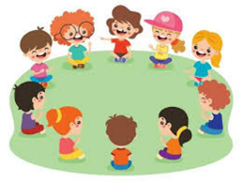

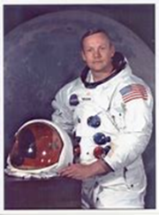
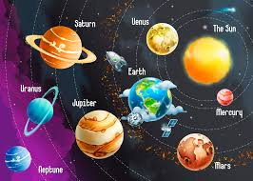
r
Expressive Arts and Design
In music, we will be exploring the units orawa and trains from our scheme Music Express.
In art we will be learning about Vincent Van Gogh. We will be exploring lines in drawing and painting techniques as we replicate some of Van Gogh’s most famous paintings. We will explore how to add white and black to colours to create tints and shades.
Maths

This half term we will be focussing on multiplication and division. Please help your children to learn their times tables for 2, 5, 10 and 3. There are lots of games online that you can use on the link below:
ictgames || Multiplication & Division

History

We will be learning about significant
people from the past this half term,
with a focus on the moon landing
and Neil Armstrong.
We will look at timelines and sources
of evidence, discussing how we know that the moon landing happened.

RE

In RE we will continue the unit ‘Who is Jewish and what do they believe?’ We will explore precious artefacts and listen to key stories.
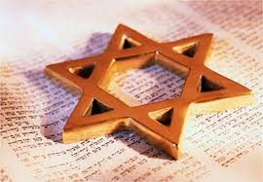

PSHE

Our PSED focus is Growing Up. We will be talking about how we have changed since we were a baby, how we care for babies and naming our body parts, using correct terminology. We will discuss which parts of our bodies are private.
The whole school focus this half term is on Honesty which we will be discussing during our circle time sessions and assemblies.

Physical Education

We are focussing on invasion games this term in our Tuesday PE sessions. This will include dribbling the ball with increasing control using both left and right foot, taking part in invasion games, trying to win.
The children will also learn to shoot the ball from different distances.

