
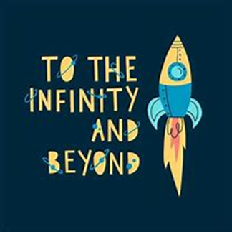


Communication and Language

We will be having daily stories and hearing lots of poetry, rhymes and songs. There will be lots of opportunities this term to talk about the
world, and to listen to others
talk too.

Term: Spring 2
English

Our main texts this half term will support our To Infinity and Beyond topic: Man on the Moon and Toys in Space.
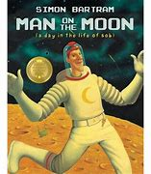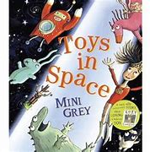

This half term we will be securing our knowledge of the phase 3 digraphs and trigraphs that we learned last half term in phonics. Our writing focus will be writing short sentences using capital letters, finger spaces and full stops.
Reception Class - Lons Infant School
Teachers: Mrs Powell and Miss Cross
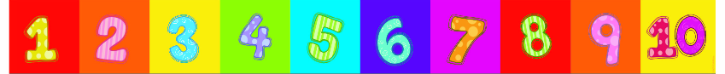
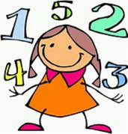
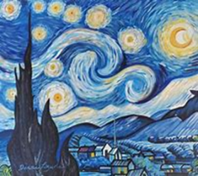
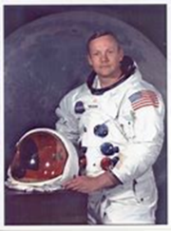
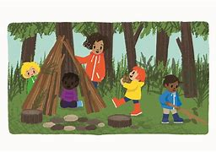
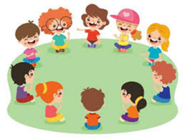



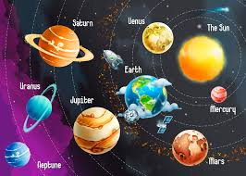
Understanding the World

We will be learning about significant
people from the past this half term,
with a focus on the moon landing
and Neil Armstrong.

In RE we will listen to religious stories and talk about special times with particular focus on the Jewish faith.

Welly Wednesdays will continue this half term. We will be talking about how we can show care for living things and our planet, we will be working as a team to build dens and also be looking for changes in the forest and signs of Spring.

Expressive Arts and Design
In music, we will be exploring the units orawa and trains from our scheme Music Express.
In art we will be learning about Vincent Van Gogh. We will be exploring lines in drawing and painting techniques as we replicate some of Van Gogh’s most famous paintings.
Maths

This half term we will begin by looking at length, height and time in our maths sessions.

We will then move on to exploring the numbers 9 and 10 and the composition of them.

We will finish the half term looking at 3D shapes, naming them and exploring their features.

Personal, Social and
Emotional Development

Our PSED focus is Growing Up. We will be talking about how we have changed since we were a baby, how we care for babies and naming our body parts.
The whole school focus this half term is on Honesty which we will be discussing during our circle time sessions and assemblies.

Physical Development

We are focussing on invasion games this term in our Tuesday PE sessions. This will include dribbling the ball and passing and receiving the ball using different body parts.
This half term all of the reception children will get the opportunity to take part in two ‘balanceability’ biking sessions to gain confidence on balance bikes and hopefully develop to rising a bike with pedals.

