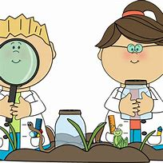
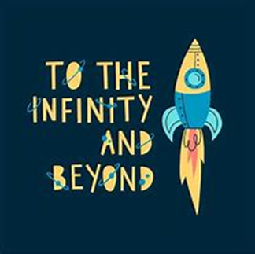

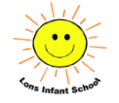
Science

We will be finishing off our learning on the seasons at the beginning of this half term before moving on to exploring how we can care for the planet.
Towards the end of the half term,
we will begin to look at plants and
trees and name their parts.

Term: Spring 2
English

Our main texts this half term will support our To Infinity and Beyond topic: Man on the Moon and Toys in Space.
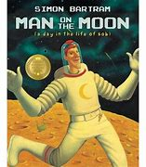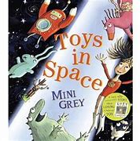

Our writing focus will be writing sentences using capital letters, finger spaces and full stops and re-reading our writing to check for sense. We will also begin to use exclamation marks in our writing.
Year One - Lons Infant School
Pine Class and Oak Class
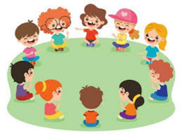
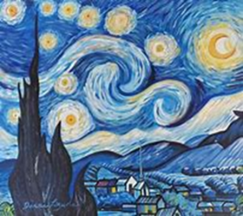
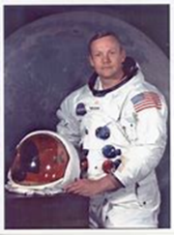
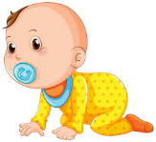
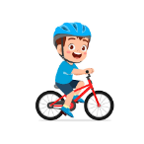
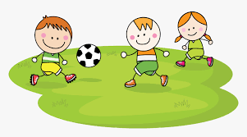
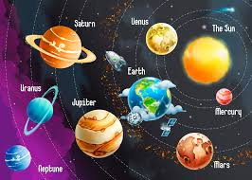
r
Maths

This half term we will begin to look at the place value and composition of numbers up to 50, slitting them into tens and ones, counting forwards and backwards and ordering numbers.

We will also look at length, height, mass and volume.
History

We will be learning about significant
people from the past this half term,
with a focus on the moon landing
and Neil Armstrong.
We will look at timelines and sources
of evidence, discussing how we know that the moon landing happened.

RE

In RE we will continue the unit ‘Who is Jewish and what do they believe?’ We will explore precious artefacts and listen to key stories.
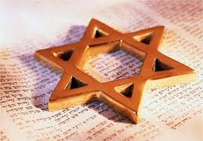

Expressive Arts and Design
In music, we will be exploring the units orawa and trains from our scheme Music Express.
In art we will be learning about Vincent Van Gogh. We will be exploring lines in drawing and painting techniques as we replicate some of Van Gogh’s most famous paintings.
PSHE

Our PSED focus is Growing Up. We will be talking about how we have changed since we were a baby, how we care for babies and naming our body parts. We will discuss which parts of our bodies are private.
The whole school focus this half term is on Honesty which we will be discussing during our circle time sessions and assemblies.

Physical Education

We are focussing on invasion games this term in our Tuesday PE sessions. This will include dribbling the ball with increasing control and taking part in invasion games, trying to win.
This half term all of the Year One children will get the opportunity to take part in two ‘balanceability’ biking sessions to gain confidence on balance bikes and hopefully develop to rising a bike with pedals.

